Assignment 2 by Garcia Anthony John Abril (4321819)

# Part 1

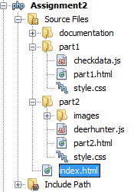

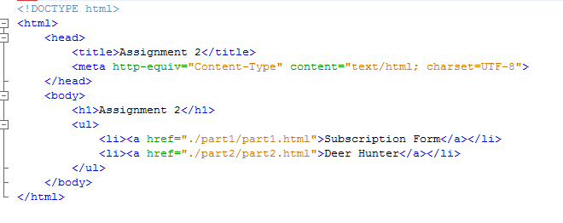

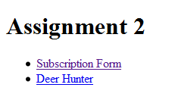

Directory of Assignment 2 Main menu for the assignment is index.html

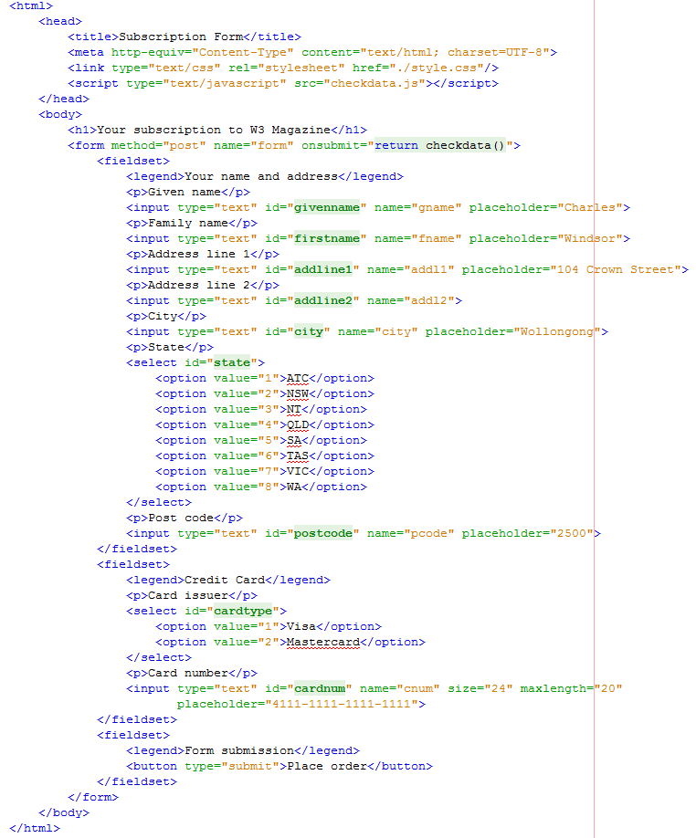

This is part1.html which includes a form, text inputs, select-option for state and card type.

The function checkdata() is called upon submission of the form. If a false is returned the form is not submitted.

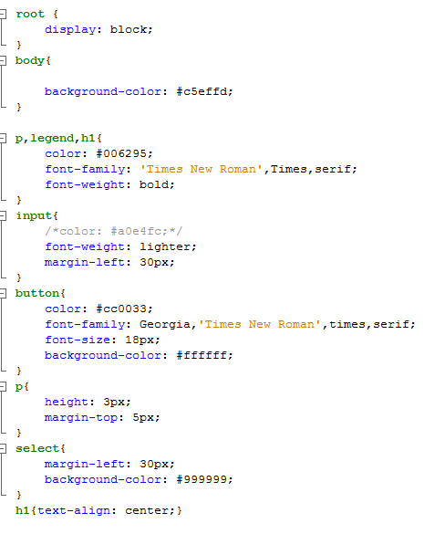

This is styles.css for the form of part1.

Color for input is changed to black as the color given in the assignment makes it difficult to read the input text.

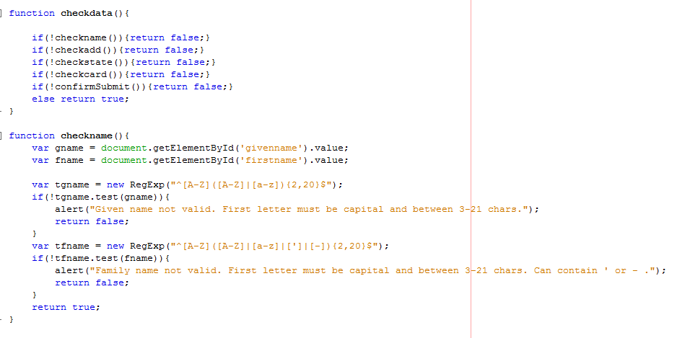

The function checkdata() contains all other sub functions which checks different parts of the form. The ‘if’ statements allows the sub-functions to return false to the form is a fault is found.

The function checkname() checks for the given and family name. The input data are obtained by id then a regexp function is used to compare whether the first letter is a capital, then compares the rest of the input with either a capital letter or a small letter for both names and a ‘ or a – for the family name. Return false is sent if fault is found.

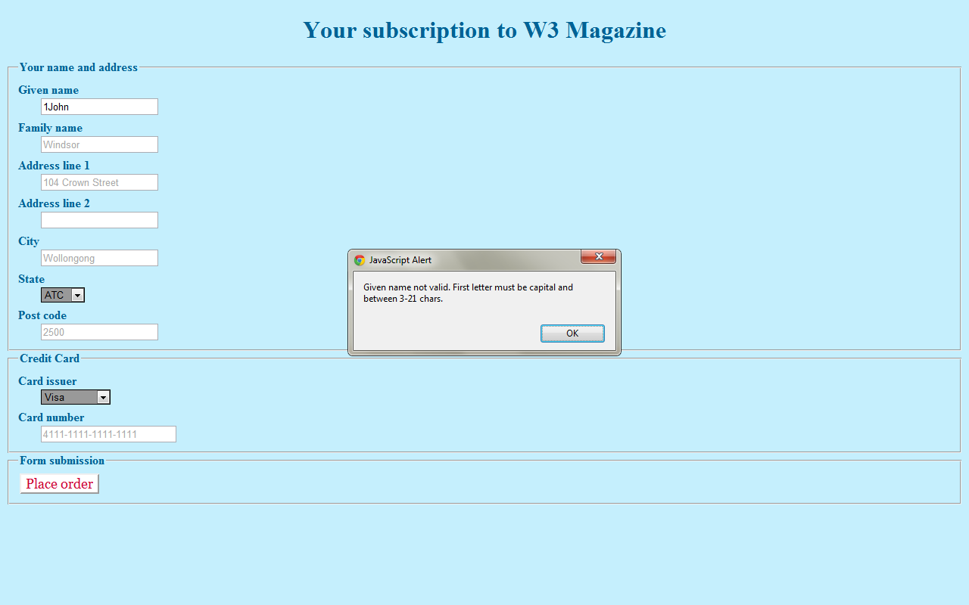

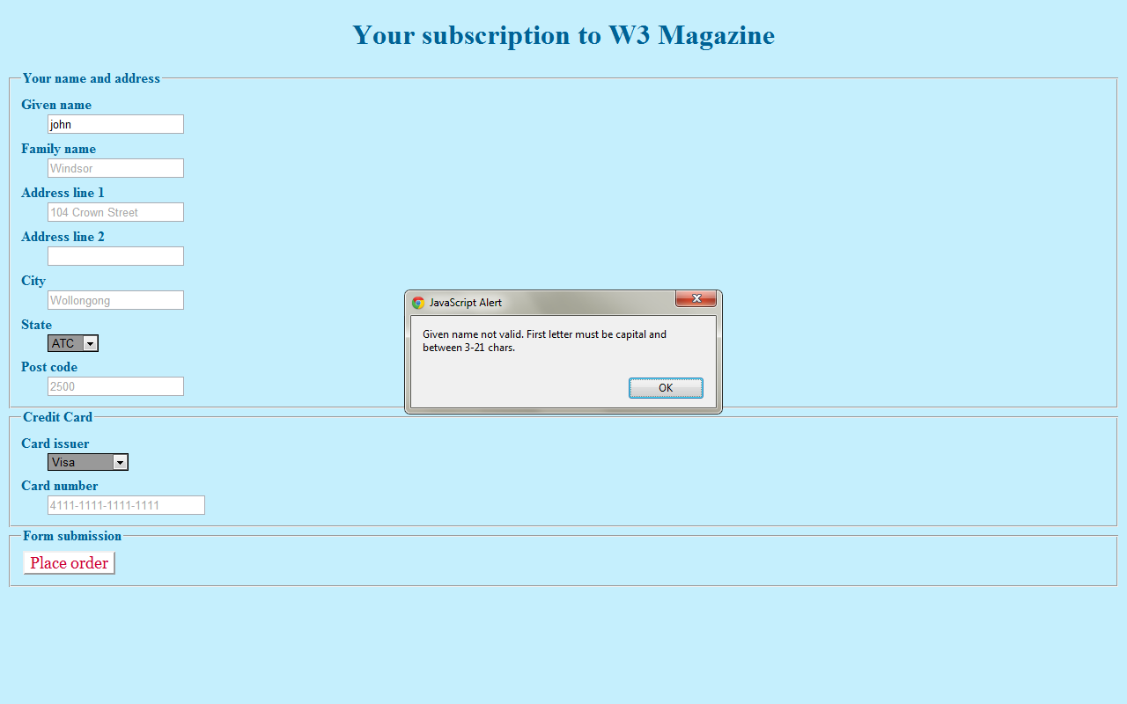

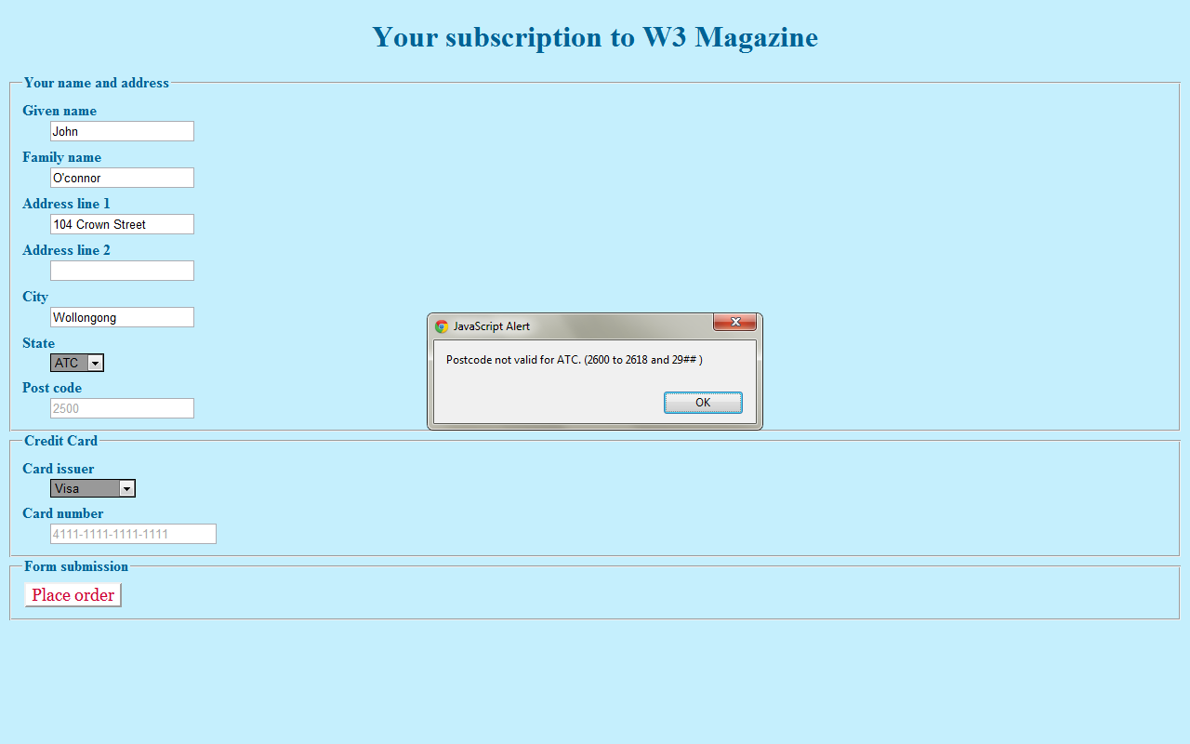

First check shows that numbers are not allowed in the first name. Second shows that first letter must be capital. Third shows that a ‘ is allowed in the family name.

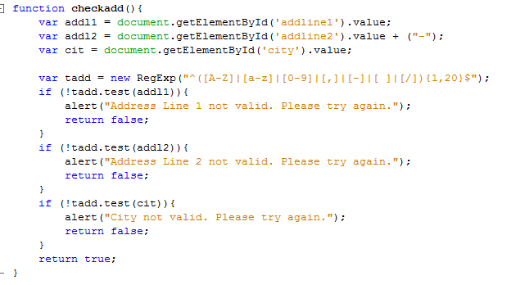The function checkadd() checks the values inside address line 1 and 2 and city. It checks the data by regexp also. Only alphabets, numbers, comma, dash and hyphen are allowed. For the line 2 a dash is added at the end to allow no data input.

The picture above will show that an empty line 2 functions proper

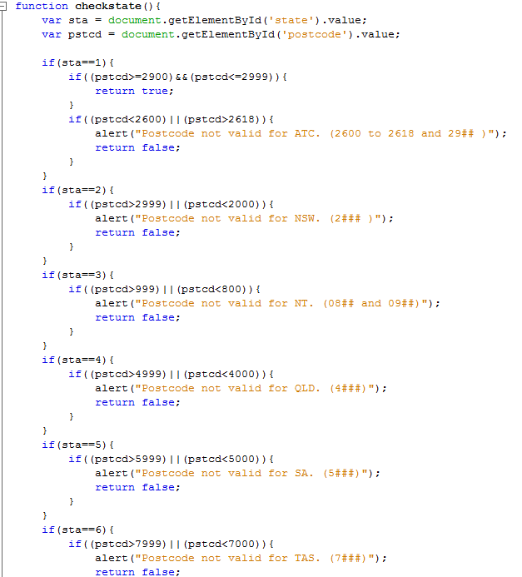The function checkstate() checks whether the postal code input matches with the requirement of each respective state.

For ATC a return true is sent if the postal code is 29## and false if it is less than 2600 or more than 2618. The higher value (29##) returns true first so that a false won’t be returned when a >2618 is encountered.

The other if statements are similar, they check the value of the postal code whether it fits the criteria.

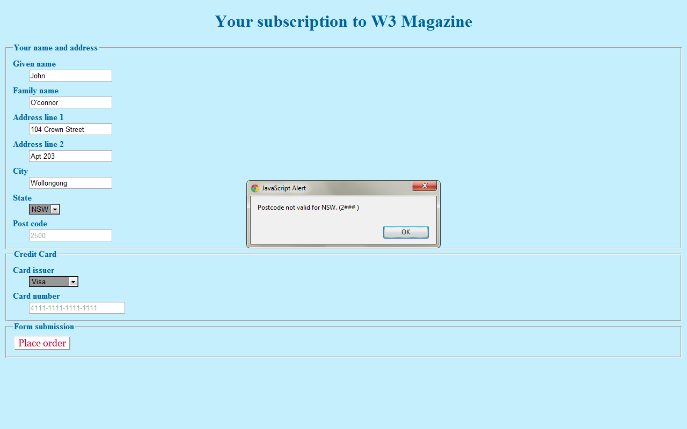

Here is can be seen that a specific state asks for a specific postal code.

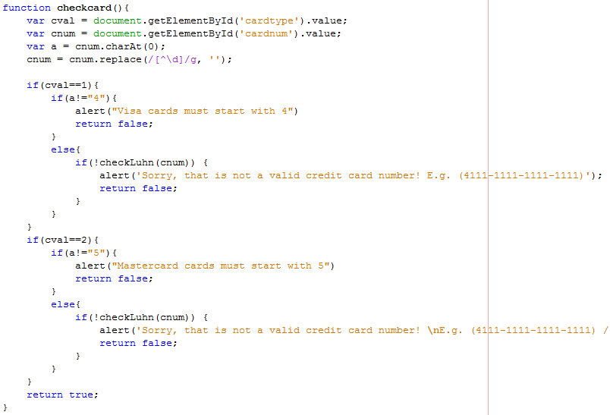

The function checkcard() checks for the card number. The function cnum.replace replaces non-digit characters (\d) found globally or the whole line (/g) with nothing ‘’. This is to remove any dashes placed by user in the credit card number input. Then a first digit is checked with the card type. Then finally the whole card number is checked with checkLuhn() which is a function I found on the internet to check validity of credit card numbers.

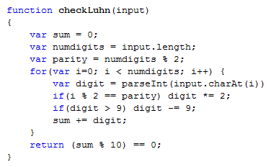

This is Luhn’s algorithm.

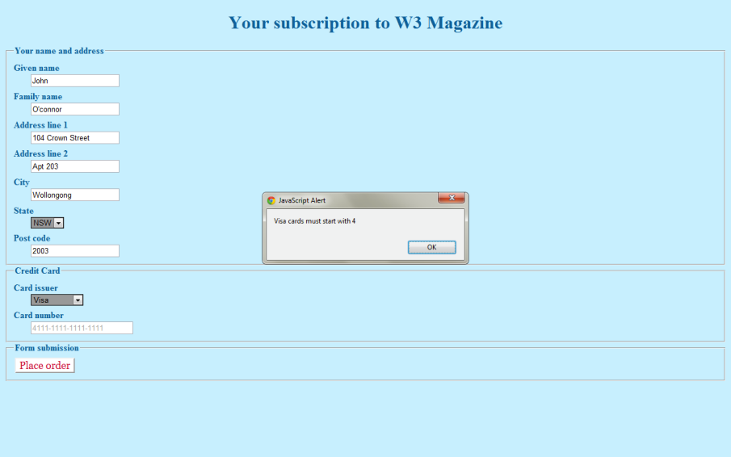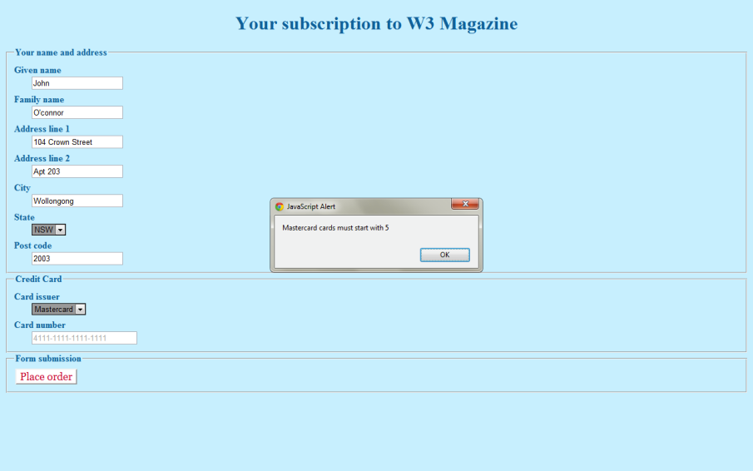The first characters are checked with each specific card type.

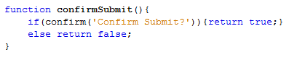

The function confirm Submit() confirms whether or not the form should be submitted upon successful validation.

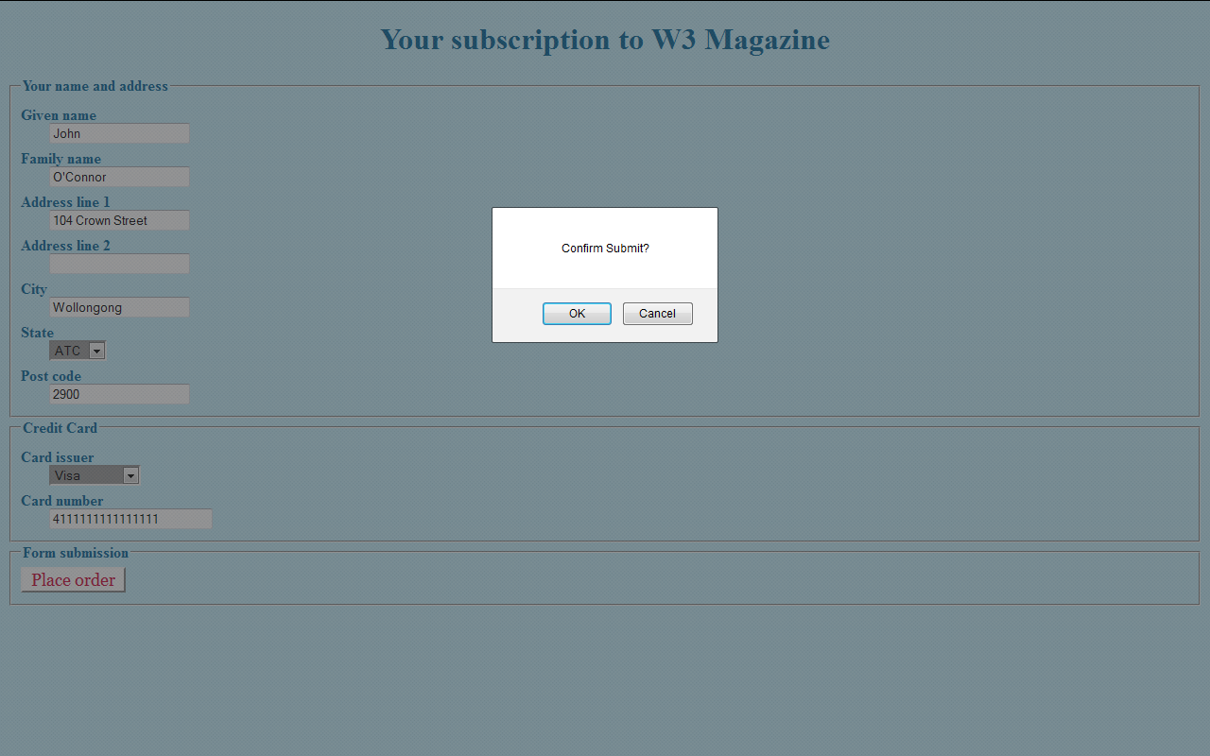

Here is the confirmation box

# Part 2

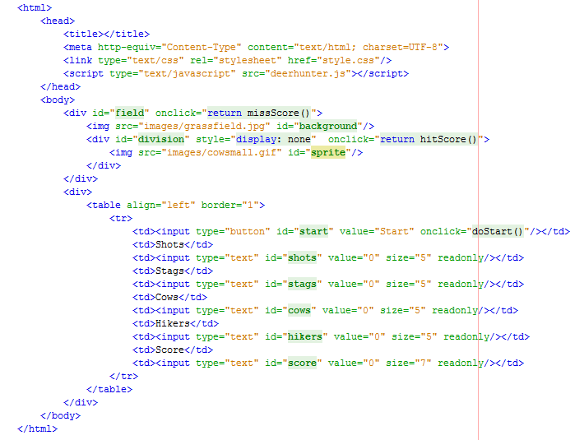

This is part2.html. It links to a javascript deerhunter.js and a css file styles.css. It contains 2 div sections and a table. The first div section is the “field” or the wallpaper of the game. Upon clicking anywhere on the div, missscore() is called. The number of shots is decreased. The second div which is in the first div is the sprites or targets. Its display style is hidden at first so that the first image cannot be seen and upon clicking on any of the sprites, the hitscore() function is called. The score is added and updated in the score board. The table contains a start button and text inputs. The start button starts the game and the function doStart() is called. The text inputs are readonly and are update by the javascript.

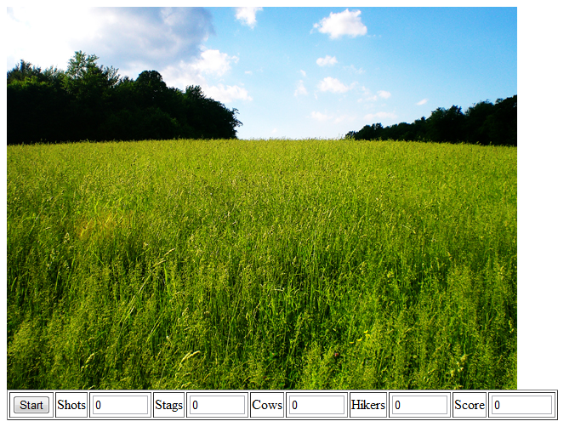

Before the start button is clicked

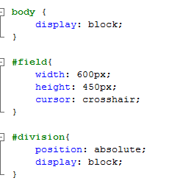

This is the css of part2. The field div is set to a fixed width and height which is the width and height of the background image. The cursor is also changed to crosshair within the field div.

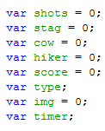These are global variables throughout the javascript.

“Shots” is the number of shots remaining. It is reset to 20 in doStart().

Stag, cow and hiker are the variable of how many times each type of sprite was hit.

Score is total score. Type is the type of sprite that was hit. Img stores the image array.

Timer keeps track of the loop.

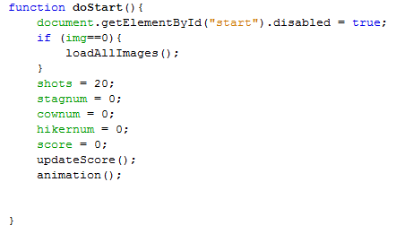

This is the function doStart(). It starts by disabling the start button. Then load the images to the array if it is empty. The values are reset (in case of another round of game). updateScore() is called. This updates the values in the table. And animation() is called.

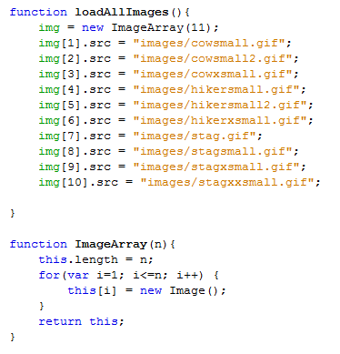

This function loadAllImages puts the images into an array. Firstly, the function ImageArray is called to create the array stack. Then the array is returned and the images are loaded one by one.

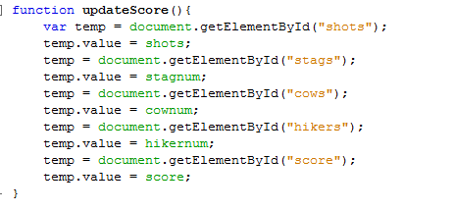This is the function updateScore(). It updates the values in the table. A variable temp is created. It obtains the data from specific text input and replaces the value with the stored and updated value from the javascript.

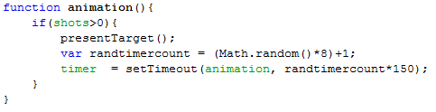

This is the function animation. It detects whether there is any shots left. If none it does not run anymore. It runs the function presentTarget. It has a variable randtimercount which is a value between 1-8. It is multiplied by 150 to get the total time for a sprite to be shown. setTimeout recalls the function animation again to create the loop and timer is a variable to keep track of the loop and be able to stop it once shots = 0.

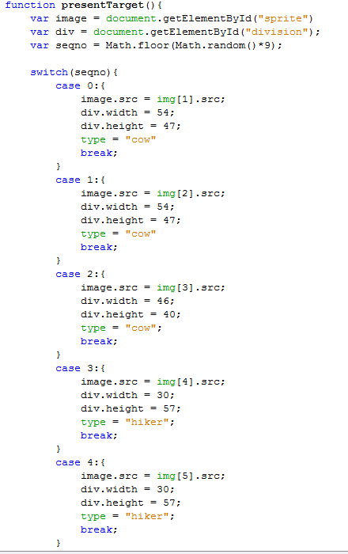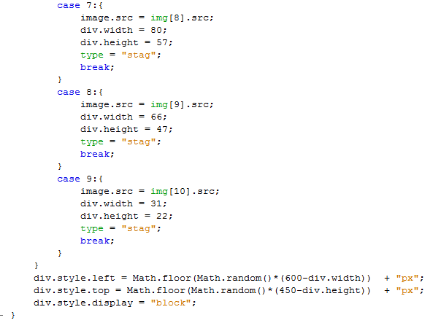

This is presentTarget function. The first sprite from the second division is loaded. The second division is also loaded. A random number is generated for the cases of different sprites. The second division is resized to exactly the size of the sprite to prevent misses being counted as hit. The division’s top and left style are also resized to move the sprites and make them appear in random places. The size of the first div subtracts the current sprite’s size to prevent it from going out of the picture. Then the display style is changed from hidden to block so that the image appears in the div.

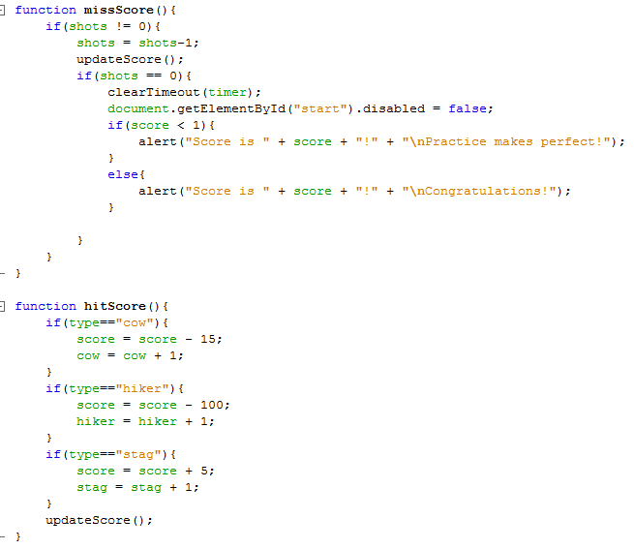

The function missScore is called when the first div is hit. This allows the subtraction of shots and updating of scoreboard. And at the same time check if the game must end (no more shots left). The score is shown and the start button is enabled again.

The function hitScore is called when a sprite or second div is hit. The Sprite that was hit will determine the score added in this function. At the same time when this function is called. The missScore function is called as well because they are overlaid and thus the number of shots is also reduced.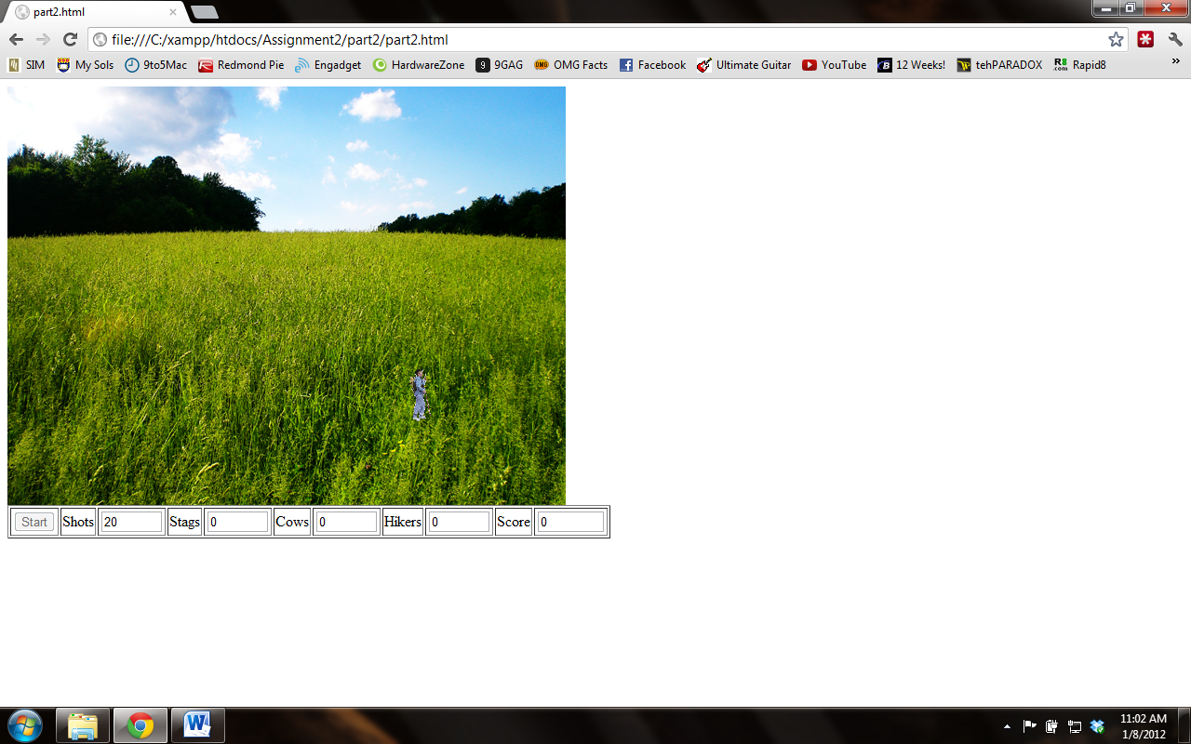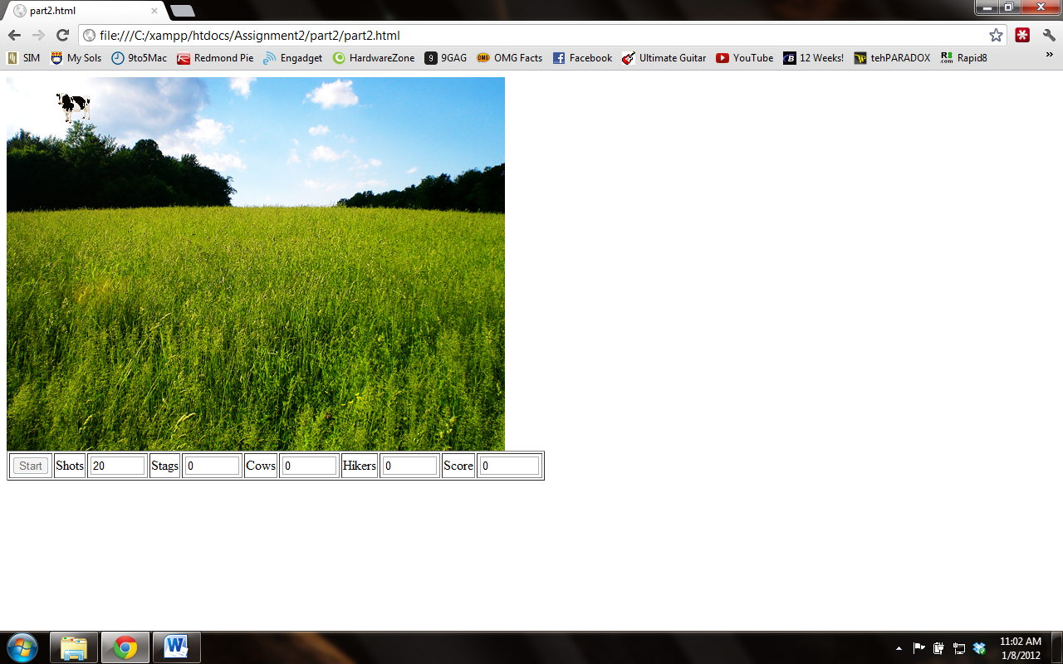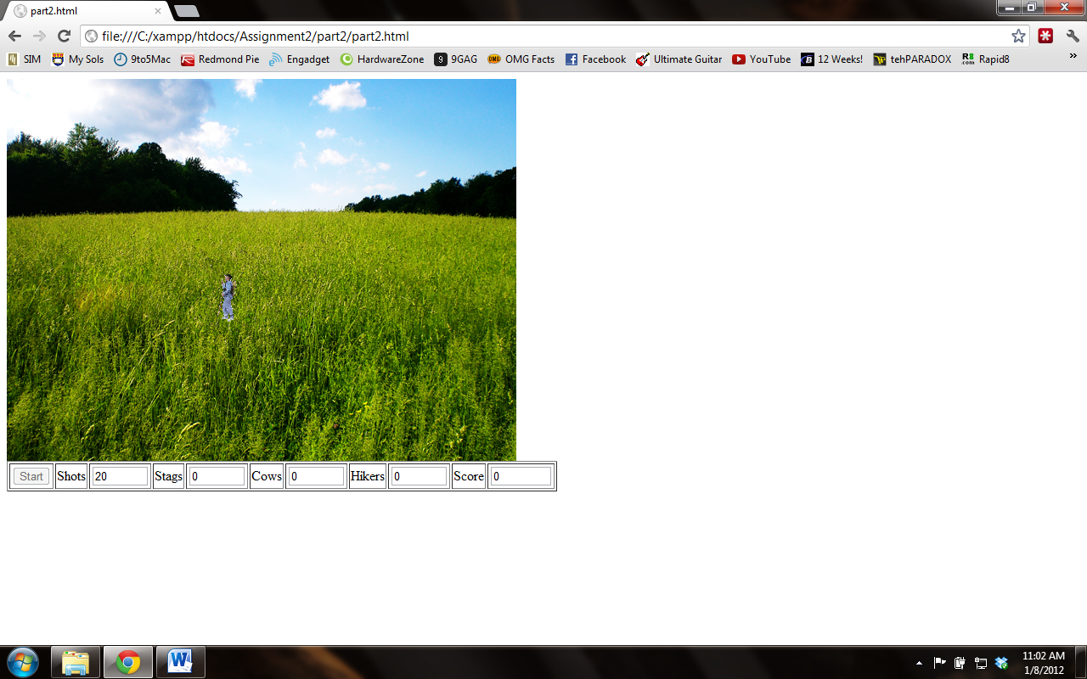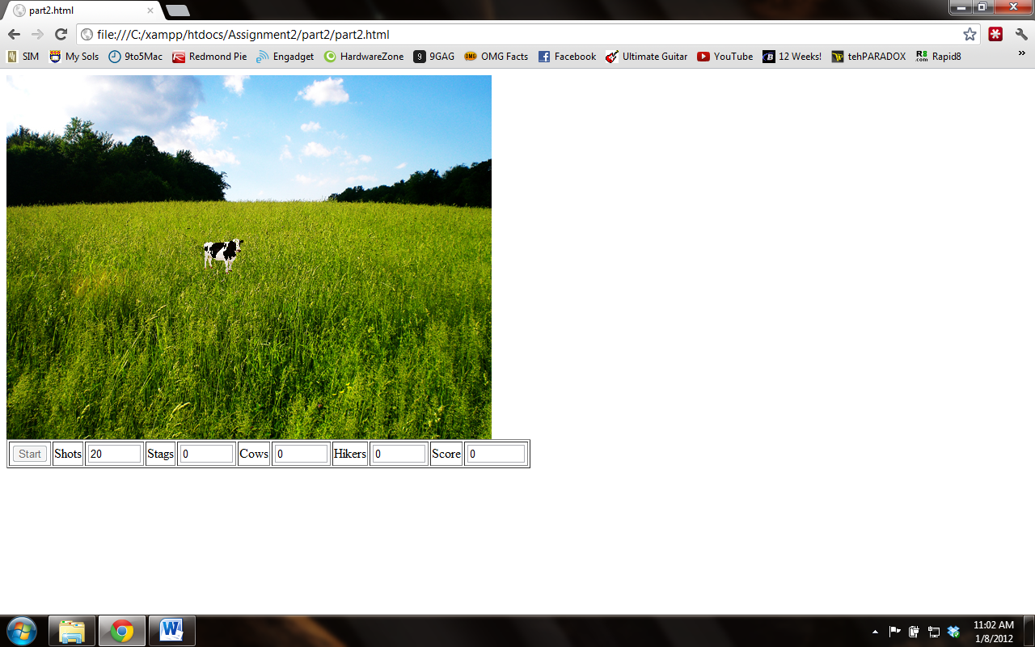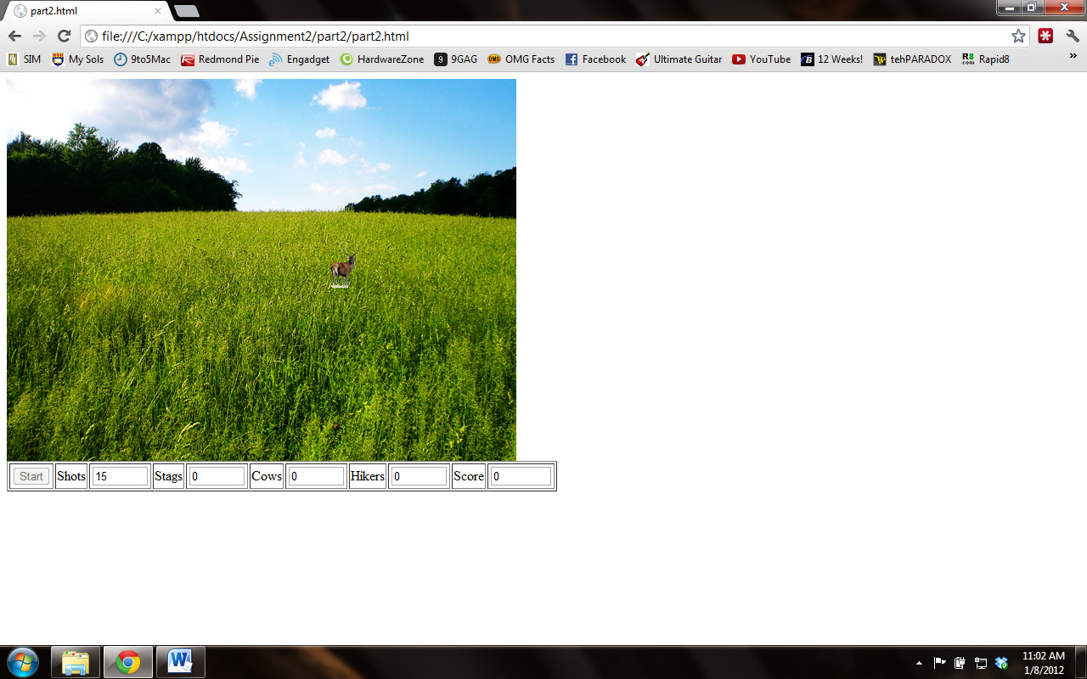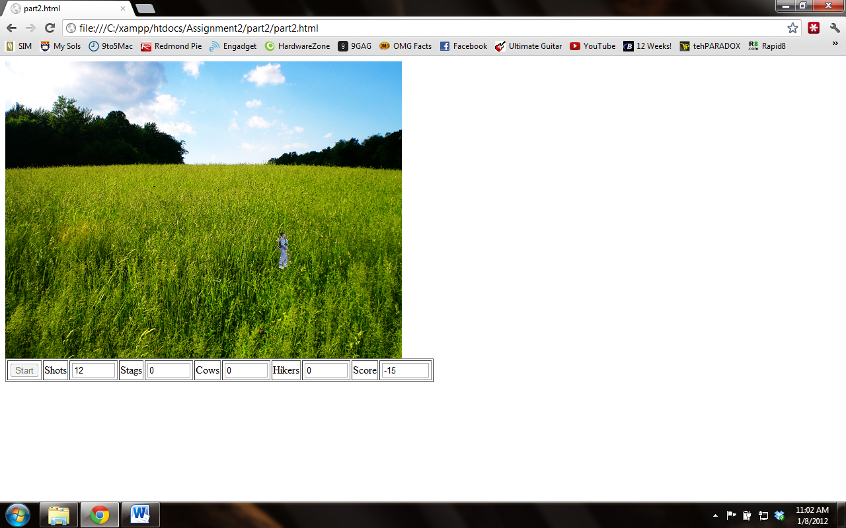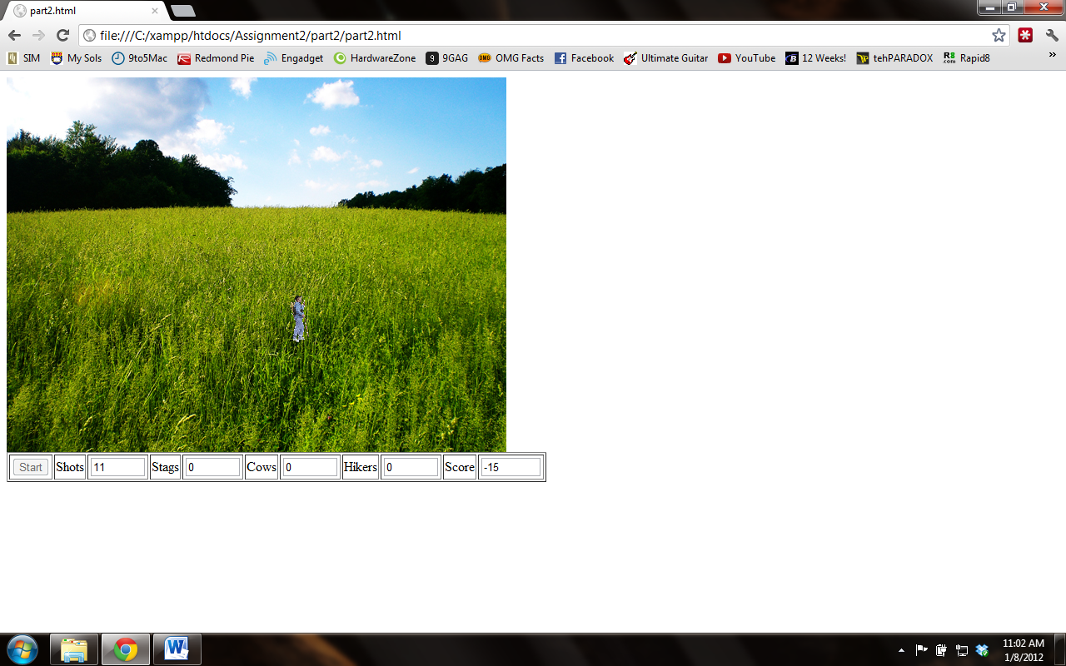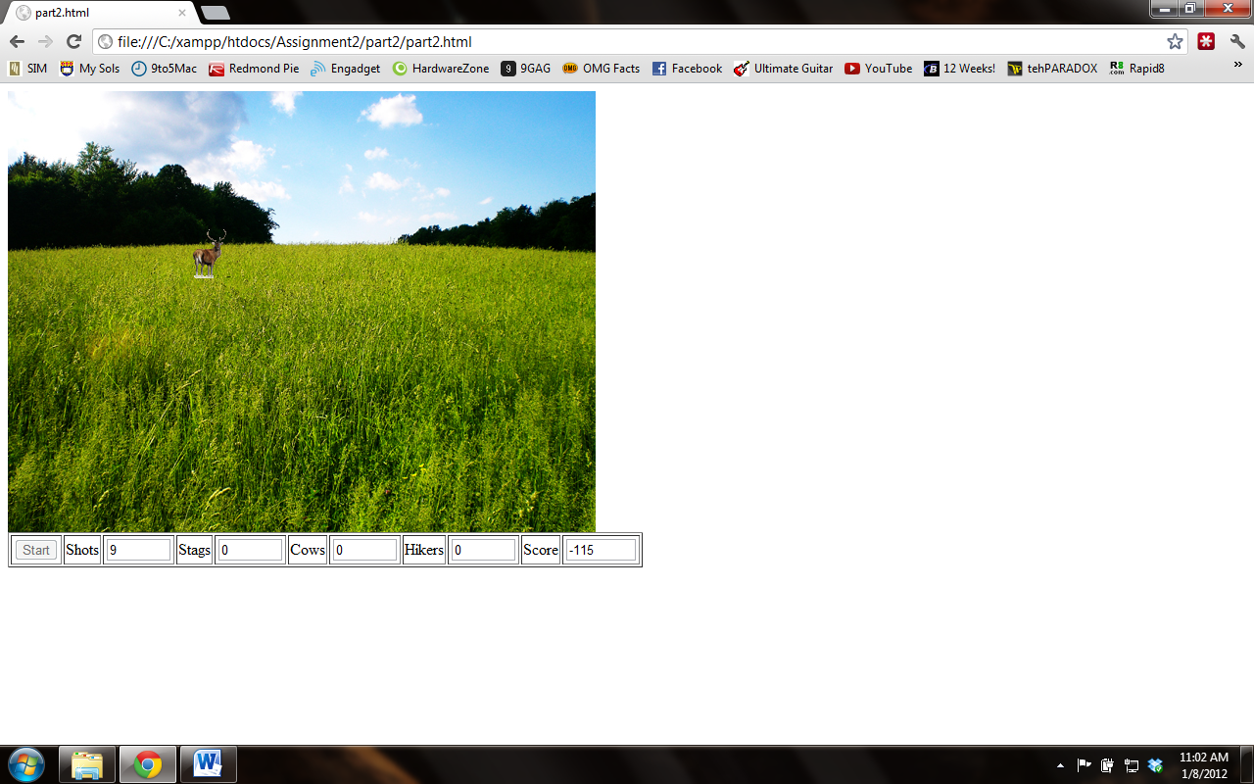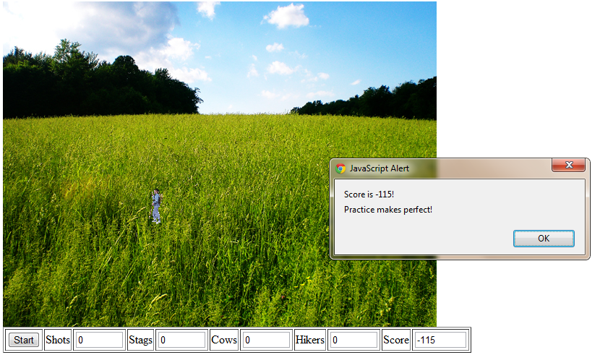

Proof of working script